CSA0613
Design and Analysis of Algorithms
CO2_ASSESSMENT TOOL 2_SCENARIO-BASED

Murali Krishnan N (192524090)
Q25.A document scanning tool matches keywords using brute-force string matching in large files.

a) Problem Understanding & Context Analysis
Scenario
A document scanning tool is used to search for a specific keyword (pattern) inside a large document (text). The objective is to determine whether the keyword exists and, if found, identify its position.
Problem
As the size of the document increases, the algorithm must compare the keyword with many positions in the text. Therefore, understanding the efficiency of the search algorithm is important.
b) Application of Concepts
Concept Used
The Brute-Force String Matching Algorithm compares the pattern with the text one character at a time.
Working Steps
- Start from the first character of the text.
- Compare the pattern with the corresponding characters in the text.
- If all characters match, the pattern is found.
- If a mismatch occurs, shift the pattern by one position.
- Repeat until the pattern is found or the text ends.
Example
Text: DOCUMENTSCAN
Pattern: SCAN
The algorithm checks every possible position until it finds SCAN.
Algorithm
Step 1: Read the text and pattern.
Step 2: Start comparison from the first position.
Step 3: Compare characters one by one.
Step 4: If all characters match, display the position.
Step 5: Otherwise shift the pattern by one position.
Step 6: Repeat until the end of the text.
Step 7: If no match is found, display "Pattern Not Found".
Python Code
INPUT
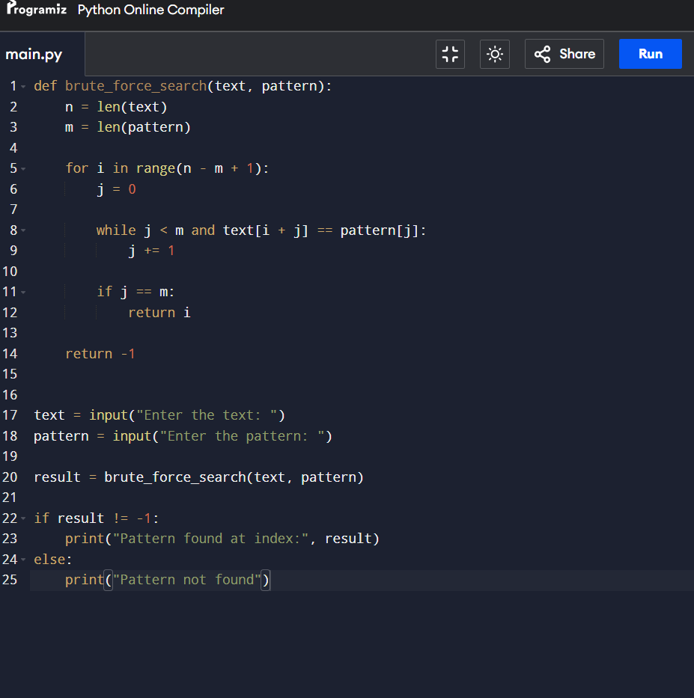
OUTPUT
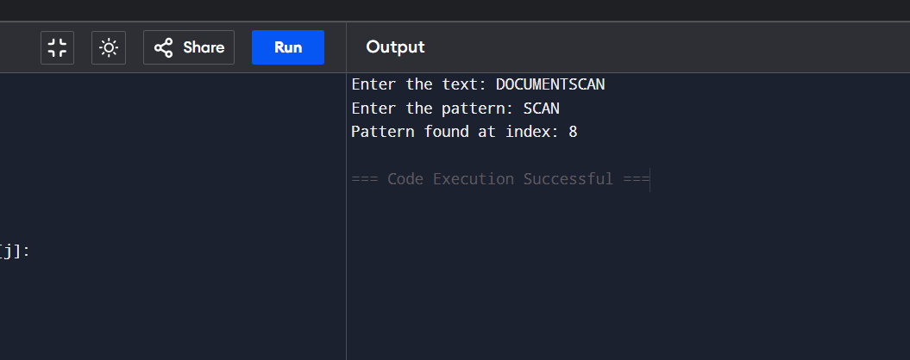
c) Analytical & Decision-Making Skills
Time Complexity
Let
- n = Length of the text
- m = Length of the pattern
Case | Time Complexity
Best Case | O(n)
Average Case | O(n × m)
Worst Case | O(n × m)

Space Complexity
O(1)
Analysis
- The algorithm compares characters one by one.
- In the worst case, it checks almost every position in the text.
- As the document size grows, the number of comparisons increases significantly.
- Therefore, the execution time becomes slow for very large files.
d) Solution Design & Approach
Solution Approach
- Accept the text and keyword as input.
- Compare the keyword with every possible position in the document.
- Stop immediately when the keyword is found.
- If the keyword is not found after checking all positions, display "Pattern Not Found".
Flow
Start
↓
Read Text and Pattern
↓
Compare Characters
↓
Match?
┌───────┐
│ Yes │ → Display Position → Stop
└───────┘
│
No
│
Shift Pattern by One Position
│
Repeat Until End of Text
│
Pattern Not Found
│
Stop
e) Clarity, Justification & Presentation
Inefficiency Issues
- Performs many repeated comparisons.
- Does not skip unnecessary character checks.
- Execution time increases rapidly for large documents.
- Not suitable for large-scale document scanning.
Better Alternative
Algorithms such as Knuth–Morris–Pratt (KMP) and Boyer–Moore are more efficient because they reduce unnecessary comparisons and improve search performance.
Conclusion
The Brute-Force String Matching Algorithm is simple and easy to implement for searching keywords in documents. However, its worst-case time complexity of O(n × m) makes it inefficient for large files because it repeatedly compares characters. For real-world document scanning systems, advanced algorithms such as KMP or Boyer–Moore are preferred due to their faster execution and better scalability.

